Interpretation
County Commissioner’s Court
Monday, September 12, 2016
10:00 a.m.

AgriLife Update (see below) David Graf, Ag/NR Agent

Report on Sustainable Resource Garden Project Dan Shelton and gardeners South Side Youth Senter

Ag/Natural Resource Report 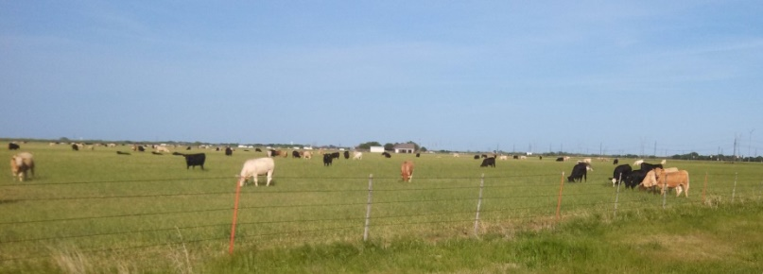
**Ag Risk Management- two marketing groups (15). Educational discussions on break even costs, risk mgt., key planning decisions.
 | Grain Only  Per Acre 1600 A. |  | Dual Purpose Wheat  Per Acre 1,100 A. |  | Grazed Out  Per Acre 500 |  | Stocker Cattle  Per Head 800  1 |  | Total  3,200 A.
Gross Revenue | $161.00 | $257,600 | $177.25 | $194,975 | $186.94 | $93,472 | $1,204.58 | $901,029 | $1,447,076
Planned Returns Above Direct Costs: | ($16.58) | ($26,521) | ($16.58) | ($18,243) | $78.87 | $39,435 | ($105.28)** | ($146,825) | ($152,154)
**these numbers were reduced to ($52.77) in July, 2016
**Bi-weekly marketing newsletters on wheat, corn, cotton (90 on email list)
**Wheat Variety Tour- discussion on 40 varieties, disease/weed control. (23)
**Cattle Trails Wheat/Stocker Cattle Conference- marketing; production mgt; health care. (101)
**Cattle Feeding/Costs Workshop- training for spreadsheet on OSU CowCulator (this week)
**Result Demos- 3rd year as part of a state wide quail study, by Rolling Plains Master Naturalists
- Soil Moisture/Temp. study with 3 probes in various wheat stubble; cover crops
- Wheat Variety Trial to plant this fall (40 varieties)
- Winter Forage Trial to plant this fall (oat, triticale, wheat)
**Educational “1-pager” revised for clients: Mesquite Control; Water Primrose;

Horticulture Update
**Site visits (30+)- Discuss issues and make recommendations: soil, forage sampling/testing; weed control; tree/shrub disease issues; herbicide damage; possible sink hole.
**Office visits (20+); phone calls (100+)- Discuss issues and provide recommendations on:
rodent control; weed control; herbicide mgt; tree/shrub, pecan mgt; Kissing Bugs; ZIKA information.
**Master Gardener’s educational booth at Farmers Market this summer (2800+ contacts)
Composting; vegetable gardening; adapted landscape plants; rainwater use; mulching; drip irrigation
(6) 4-Hers helping as teen leaders
**Community service/Master Gardener Xeriscape garden at MPEC- cleanup and care
(4) 4-Hers helping as teen leaders
**Result Demo- Rose Rosette Virus- 60 plants—10 varieties rating resistance/susceptibility
**Result Demo- Soil Moisture Sensors- monitor amount and depth of water uptake (trees; lawns)
**ZIKA Mosquito Surveillance as part of state wide effort.
**M.G. Intern class- 15 attend 16 in-depth classes (50 hours); plus volunteer 50 hours.
**Educational “1-pager” revised for clients: Khaki Weed Control; Tree Borers

Sustainable Resource Garden Project Update
Volunteers (11) helping kids (828) learn: planting,care, watering with rainwater, nutrition. Also teaching: teamwork; “no effort, no food”; mother nature is at your mercy; “growing my own food tastes good”.
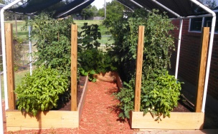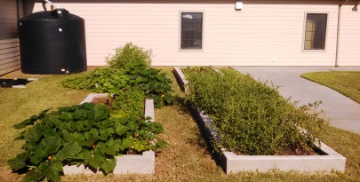
River Bend Nature Center 634
Central B&G Club 13
Notre Dame 21
Faith Refuge 40
S. Side Youth Senter 120
TOTAL 828

Youth Water SPLASH [throwing away a burger wastes 600 gal. water; landscape is 35% of water use]
Central Boys & Girls Club (52 kids) + (5) 4-Hers as teen leaders
Group discussions as a “Water Board” determining use for hospital, home, ball field, food, water reserve. Water conservation in home and landscape.

Summer 4-H Effort
2016 State Fair Livestock Validation and 2017 State Steer Validation - steers, heifers, lambs (20+)
State 4-H Roundup: 20 4-Her’s attended— Tres Hunter won State in Solo Performance
64th Annual 4-H Banquet/Awards (220)
Record Book judging (23) One advanced to state competion.
4-H Club Chartering - 8 Clubs

Educational programs of the Texas A&M AgriLife Extension Service are open to all people without regard to race, color, religion, sex, national origin, age, disability, genetic information or veteran status. The Texas A&M University System, U.S. Department of Agriculture, and the County Commissioners Courts of Texas Cooperating

